HOLIDAY
FUNDRAISER!
Complete your holiday shopping knowing that you will receive:

10% discount off of your purchase* &
10% will be donated to:

MANOA ELEMENTARY PTO

DATES: Monday 11/5 thru Friday 11/9
TIME: 10 am to 8 pm

CODE: MAN OA
YOU MUST BRING IN THIS INVITATION TO REDEEM YOUR DISCOUNT!

*Because the donation has already been made, returns of products after the dates above will be at 20% off.
May not be combined with any other offer, promotion, markdown, giveaways, coupons, VIP awards, or discounts. Due to the manufacturer’s restrictions, LEGO Mindstorms may not be discounted, but will still be part of the fundraiser. 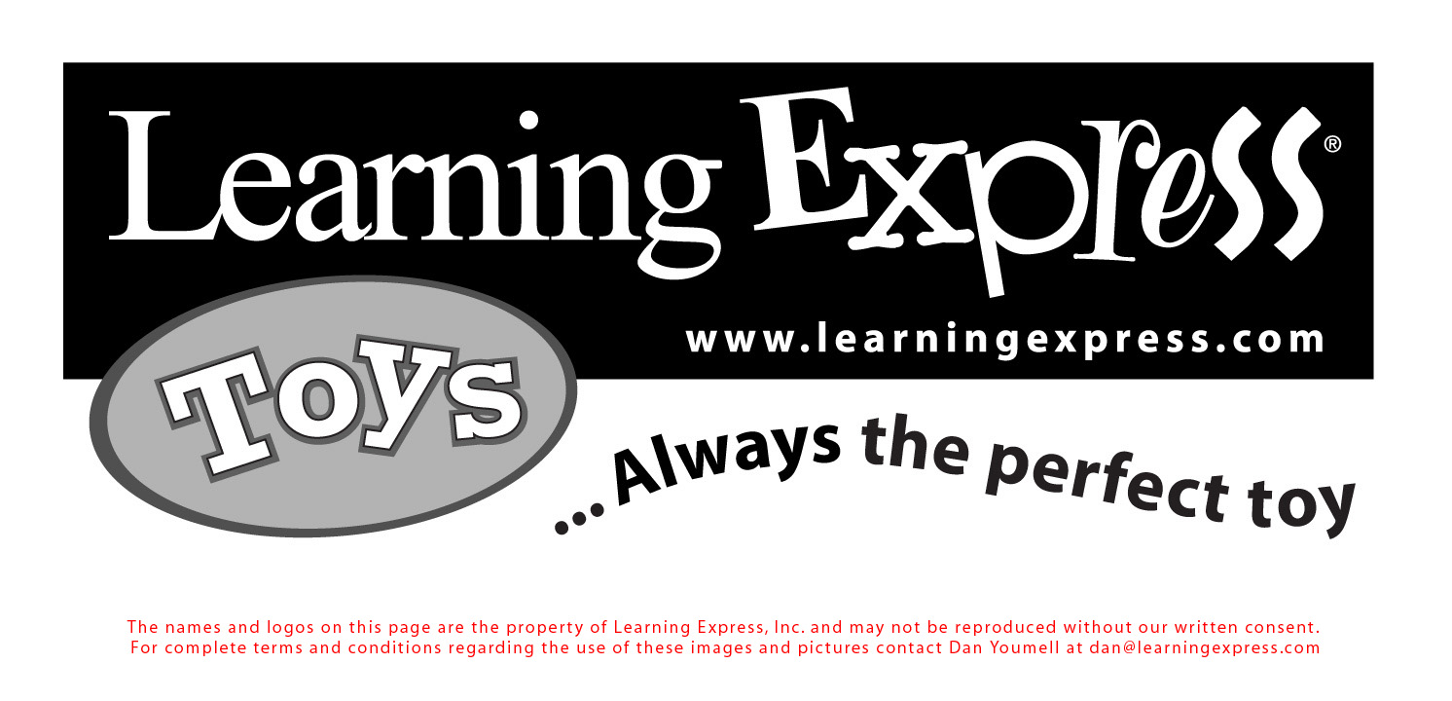
MANOA SHOPPING CENTER
1305 WEST CHESTER PIKE, STORE #23, HAVERTOWN, PA
610-352-TOYS (8697)
YOU MAY ALSO VIEW OUR CATALOG ONLINE AT https://issuu.com/learningexpresstoys/docs/holiday2018lo?e=3943721/65261763
Please do not order online as you will not get the discount, nor will the purchase be part of the fundraiser.

